**AZ-204_lab_01_Assignment**

**Build a web application on Azure platform as a service offerings**  
  
  
  
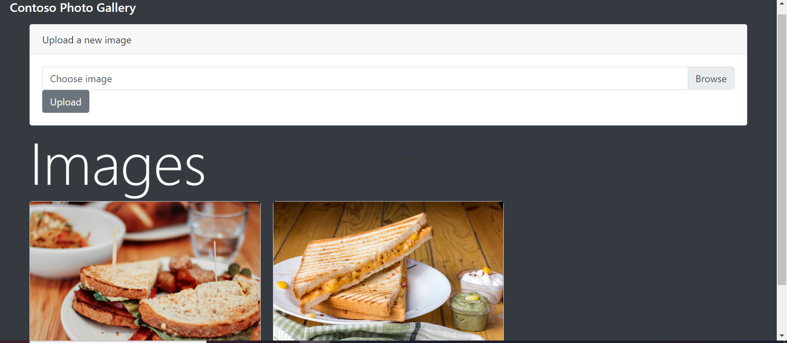

# AZ-204_lab_02_Assignment Implement task processing logic by using Azure Function

# 03 _Assignment Upload and analyze a file with Azure Functions and Blob Storage

# 

# 04_Assignment Azure SQL Database

**Lab 06: Authenticate by using OpenID Connect, MSAL, and .NET SDKs**

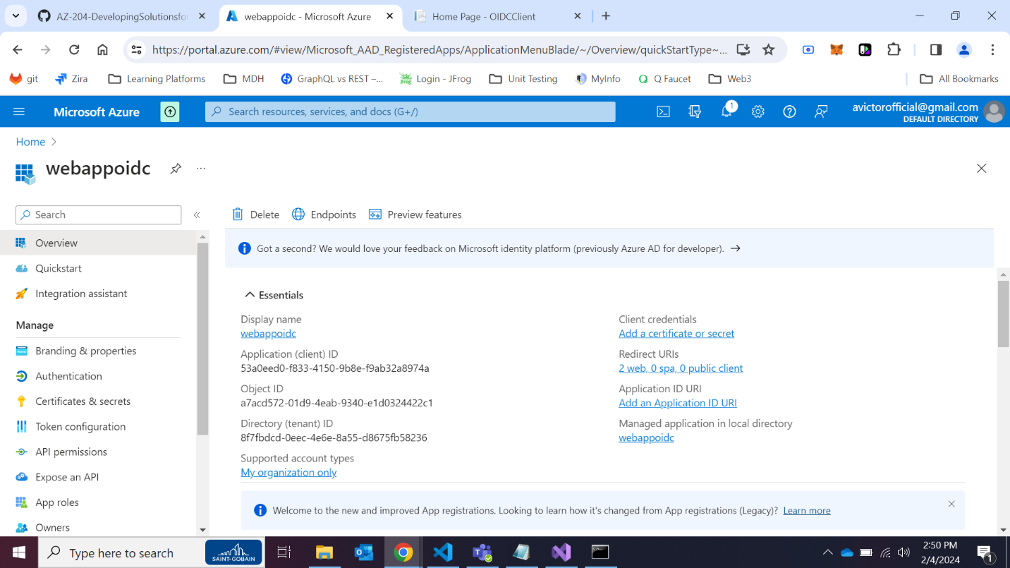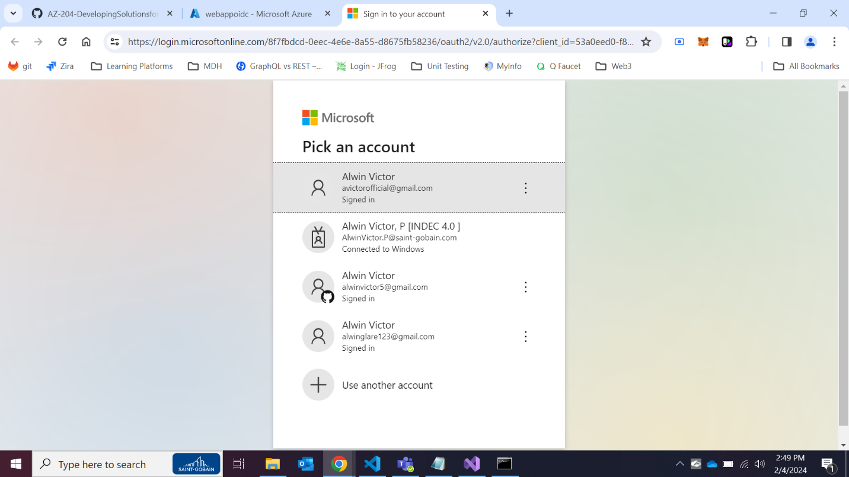

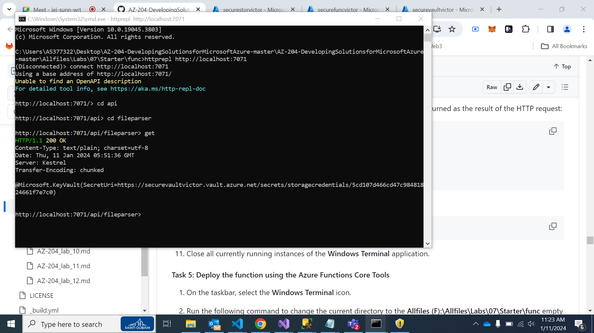

# Lab 07: Access resource secrets more securely across services

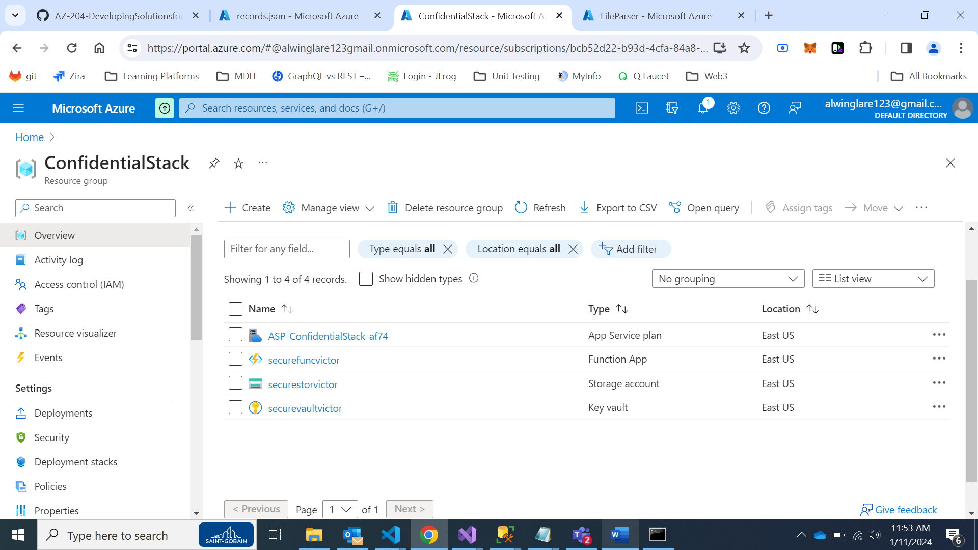  
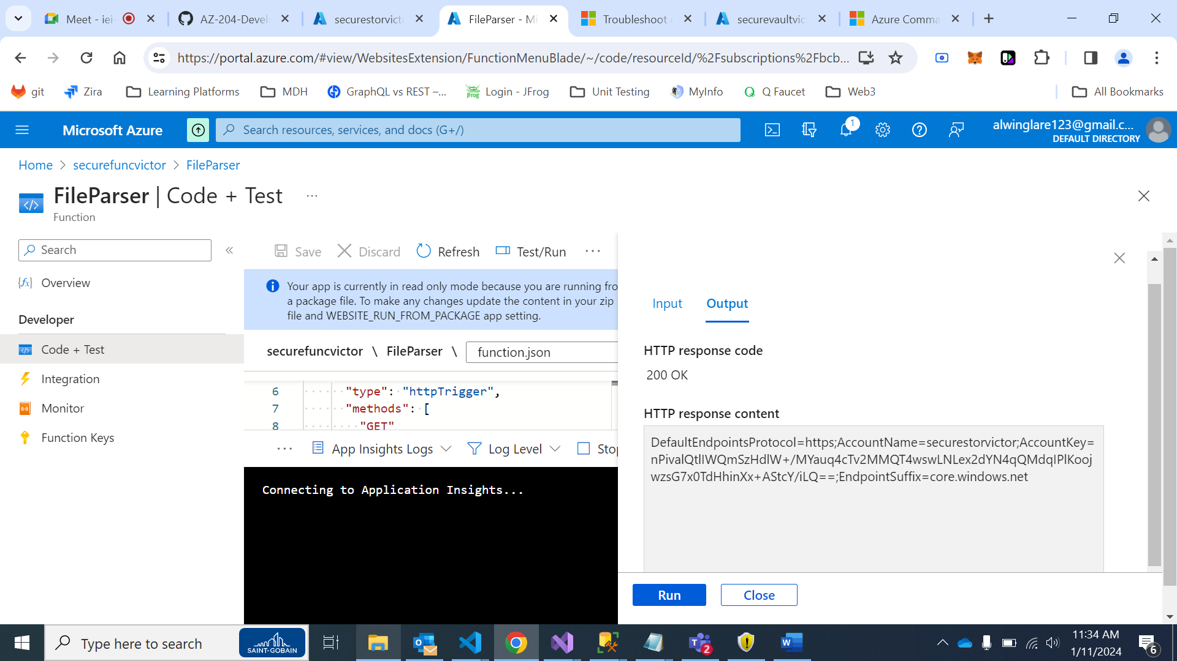

# 

# Lab 08: Create a multi-tier solution by using Azure services

# Azure Kubernates

# Lab 10: Asynchronously process messages by using Azure Service Bus Queues

